1.Write a Pandas program to select the distinct department id from employee’s file.
Aim:
To write a Pandas program to select the distinct department IDs from the employee’s file.
Program:
import pandas as pd

employees = pd.read_csv("employees.csv")

distinct_dept = employees["department_id"].drop_duplicates()

print("Distinct Department IDs:")
print(distinct_dept)
Output:
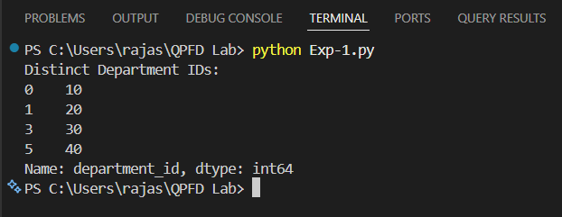
Result:
The program successfully selected and displayed the distinct department IDs from the employees file.
2. Write a Pandas program to display the IDs of employees who have done two or more

Aim:
To write a Pandas program to display the IDs of employees who have done two or more jobs.
Program:
import pandas as pd

jobs = pd.read_csv("employee_jobs.csv")

job_count = jobs.groupby("employee_id").size()

result = job_count[job_count >= 2]

print(result)
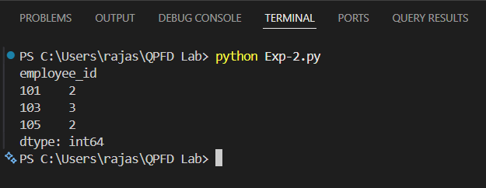
Output:

